CS351T-Project Human Computer Interaction,

Second Semester 1444- 2022

Project topic: Flowers/ Plants Order System

Lab Project

D. Fatimah Alanizi

Section: 8C6

Group No. 3

|  |  |  |
| --- | --- | --- |
| No. | Student Name | Student Number |
| 1 | Reem Alzahrani | 442004138 |
| 2 | Alanoud Alabbad | 442001985 |
| 3 | Nujud Alharbi | 442001516 |
| 4 | Waad Alsubeeh | 442004332 |
| 5 | Reeman Algarni | 442002956 |

Contents

1. Abstract 2

2. Introduction 3

3. Background information & Related work 3

3.1 Analysis 3

3.2 Users 6

3.3 Tasks 6

3.4 Interviews 7

3.5. Questionnaires 10

3.6 Functional and Non-Functional Requirements 24

4. User interface, implementation and Testing 26

4.1 Logo 27

4.2 Usability Testing 50

4.3 Analysis 55

5. Conclusion 56

6. References 56

# Abstract

In this project we design an application for ordering flowers online, we got a really satisfying outcome and what helped us is that we clarify the idea and studied similar apps, we got to know all about the users needs and backgrounds, after we gathered all important information we started on our paper prototype, convert it to high Fidelity prototype then we tested it with real users who liked their experience.

# Introduction

The project problem or idea

You want to buy a gift for your loved one on a special day so you look for the best flower shop near you, to get them flowers

which is a beautiful way to describe your feelings but you go

through traffic to get there, maybe you won find what you like or it wont be in your budget but you have no other choice.

With our app you can order a Customized Bouquets with Additional Gifts and cards in your budget plus schedule your order to not forget about it and track it. it will be delivered fast to your doorstep, without wasting time, money or energy.

The Project Purpose

Providing our customers with quality flowers and different bouquet arrangements at a fair price and of course in a simple efficient convenient way.

The system will divide the flowers into different section depending on its kind , to make the process easier.

It will also contain a flower arrangement service where the customer can arrange their own bouquet, and adding a a printed card depending

on the occasion for those who are running out of time.

It can be delivered right away or in the scheduled time,plus you can edit the order any time before three hours of the delivery time with no additional fees.

# Background information & Related work

## **3.1 Analysis**

We may encounter several problems when going to buy a bouquet of flowers, and the most important of these problems is searching for shops that provide bouquets of high quality roses, and there may be a lack of time due to urgent surprises, and also the customer may suffer in going to buy the gift with bad and crowded traffic or unfortunately, his car get damaged while he is going, which delays him in delivering the gift, and the customer may need to get ideas for coordinating his gift or pre-made models, but in flower shops they may not have pictures of their pre-models, and the customer may face when he goes to one of the gift-coordinating shops a problem with the budget of his gift,

which may be more expensive From his budget, he has to pay a

higher amount because he does not have enough time, and the customer may choose a shape from his imagination to format his gift, but after coordinating it, it may not be the desired shape that the customer wants.

In our application, we will build a flawless application that will s wishes and help him avoid all the ’also fulfill the customer previously mentioned problems. One of the most important of these problems is that we will facilitate the time for the customer, and the customer will be able to determine the appropriate time to send his gift to the required address.

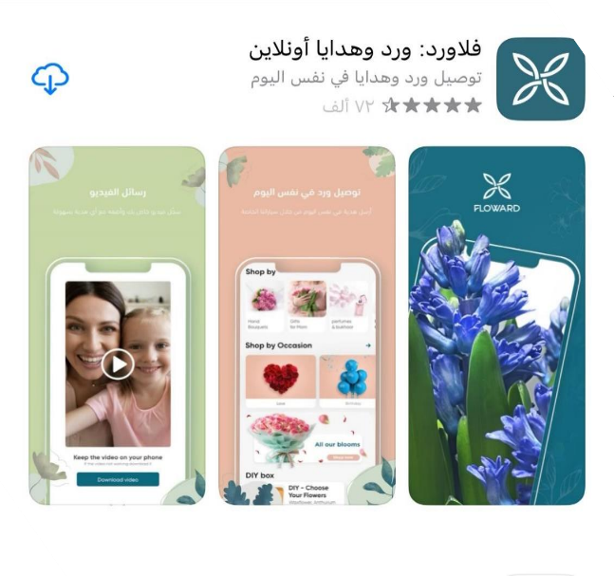

One of the positives provided by this application is determining the appropriate time for the required gift to arrive at the address of the person required, but its limited due to high prices

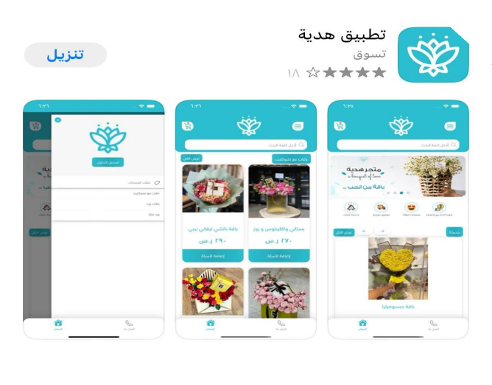

one of the positives that it provides is the availability of customer service when a problem occurs in the order but its limited delivery to certain areas only in Riyadh.

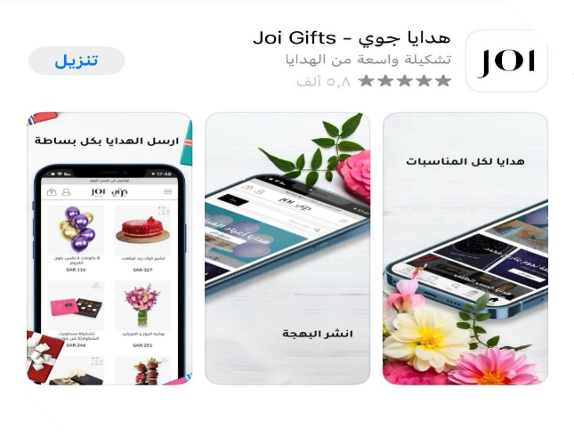

This application provide various additional gifts that can be added such as cake and others with bouquets of flowers, but canceling the order requir additional fees.

## **3.2 Users**

Primary users for the system:

1 – florist

They use the system to:

* Register customer data
* Determine the type of flowers required
* Implementation of customer requests
* Send a link to the order invoice

1. Delivery driver

The system is used for:

* + Receive customer data
  + The ability to specify the destination for the recipient’s location
  + Delivering the order to the specified location

Secondary users for the system:

1. Clients

They use the system to:

* + Choose the appropriate flower arrangement
  + Track the order directly while it is in transit
  + The ability to evaluate the request and the delivery service

In our system, we will not be able to divide users into groups, because it is possible to use our application for all age groups and all genders, whether male or female, because flowers are a language spoken by all people in the world.

## **3.3 Tasks**

First, the customer will enter the system and create an account, then log in by putting the username and the secret code, and then the customer will be able to choose the appropriate flower formats and the appropriate price for it, and gifts and cards can be added if desired, and then the customer chooses the appropriate day, time and location to receive or send the gift By putting the recipient's number to communicate with him, after that the payment options page will be displayed so that the customer will be able to pay the amount by choosing the appropriate payment method, whether it is paying the full amount or in installments, and he will also be able after completing the gift coordination by the gift coordinator, a picture of it will be displayed For the final form of the gift before it is sent, and then the customer will be able to give his opinion and make notes if he wants to, and then the customer will be able to track the order until the time of delivery of the order, and in the end the customer can evaluate the order after its delivery.

## **3.4 Interviews**

###### Reem Rashed Alzahrani (interview-1)

1. do you prefer ordering things online ? Why or why not ?

* **A:** Yes, They have more exclusive sales and discounts than in physical stores.
* **B:** No, to make sure of the quality in person
* **C:** Yes, it will save my time instead of going to the store i just order what I want

1. Describe your experience in ordering online?

* **A:** Great saves time and money
* **B:** Not good, i get scammed pretty often
* **C:** I think its Easier compared to traditional shopping

1. How much time do you typically spend buying flowers from a shop ?

* **A:** Half an hour to 40 minutes
* **B:** 50 minutes , it s hard to decide
* **C:** Takes me around 30 minutes up to an hour to decide what I want

1. How much frequently do you buy flowers in a year ?

* **A:** Every occasion
* **B:** Rarely
* **C:** Occasionally

1. Have you tried a flower ordering app ?if yes what was it?

* **A:** Yes , FLOART , bloom in
* **B:** Yes , zohor
* **C:** Yes, spring rose

1. Tell me what you like when ordering flowers online?

* **A:** Less Time Consuming and you can find the best offers.
* **B:** Provide lots of choices
* **C:** Save my time from going to the store

1. Tell me what you don t like when ordering flowers online?

* **A:** Changes in flower arrangements it doesn’t look like the pictures
* **B:** High prices
* **C:** Can t give feedback on the flowers

1. If we offer scheduling orders will you use it?

* **A:** Sure because i forget to order
* **B:** Maybe i am not familiar with it
* **C:** Yes to arrive on time

1. Would you like to be able to customizing your bouquet online?

* **A:** Yes this would be similar to going for a flower shop
* **B:** Yes
* **C:** Yes it s great

1. Would you like if you were able to chat with the florist online to decide what to bay?

* **A:** It will be nice , I like to take advices
* **B:** yes and make sure if the flowers fresh
* **C:** yes, I like to hear from specialist

1. Would you like to be able to track your order online?

* **A:** Sure To know exactly when it will arrive
* **B:** Yes
* **C:** Yes, I would like to know the expected delivery time

###### Summary:

Through out the interview results, most of the users have a similar opinion, most of them know how to order online so they will be familiar with our application , they liked all the features mentioned and willing to

t like in use them. We were able to discuss what they like and don

app to make sure that our app will win their admiration, we saw ordering

.the other ordering apps that they used to see what they are familiar with.

###### Reeman Algarni (interview-2)

1. how old are you?

User 1: 20

**User 2:** 49

User 3: 27

1. how often do you buy flowers or bouquets ?

**User 1:** Not much, just on occasions.

**User 2:** I have a big family and we have a lot of occasions so i would say pretty often.

**User 3:** When I want to buy a gift for someone.

1. what is your favorite type of flower?

**User 1:** I prefer rose and lavender.

**User 2:** I think all types of flowers are beautiful.

**User 3:** Roses are my favorite.

1. when you’re buying a specific kind of flower do you like reading information about it before ?

**User 1:** Yes I often like to read about their meanings

**User 2:** Not really.

**User 3:** No I don’t really care.

1. do you prefer buying flowers online or in store?

**User 1:** I like ordering them online when I’m on a rush but if i had the time i would go to a store.

**User 2:** I like going to a store to check the quality.

**User 3:** In store because i get to see them and arrange flowers how i like which is something you can’t find online.

1. in your opinion what are the difficulties that face you when you’re shopping for flowers online?

**User 1:** A problem may occur and the my order may not arrive on the specified date.

**User 2:** The size of the bouquet, the quality of the flowers and color arrangements. These things concern me a lot.

**User 3:** Usually they are too expensive and the design are limited.

1. what are the main services you need in an online flower shop?

**User 1:** Probably Delivery and payment upon receipt

**User 2:** Good customer service , respect time and delivering the right product. **User 3:** Ability

to customize your own bouquet and I would love if they had nice gift cards.

1. from your past experiences what would you do to improve the process of buying flowers online ?

**User 1:** Delivering to any specified place and a fast delivery.

**User 2:** Having different bouquet designs and letting the customers design their own bouquet and probably giving gift cards to a regular client.

**User 3:** Variety of options, good delivery service and focus on the quality plus the application should be easy to use to make the process easier.

1. are you interested in arranging flowers or buying a ready-to-go arranged bouquet?

**User 1:** I love arranging flowers if i have time.

**User 2:** I’m very fond of arranging flowers i think it adds a simple touch and shows that you care.

**User 3:** I would say arranging my own bouquet.

1. would You like subscribing to a monthly mail service regarding our latest updates?

**User 1:** Of course.

**User 2:** Yes I would love that.

**User 3:** Yes.

1. from your past experiences what would you do to improve the process of buying flowers online ?

**User 1:** Delivering to any specified place and a fast delivery.

**User 2:** Having different bouquet designs and letting the customers design their own bouquet and probably giving gift cards to a regular client.

**User 3:** Variety of options, good delivery service and focus on the quality plus the application should be easy to use to make the process easier.

1. are you interested in arranging flowers or buying a ready-to-go arranged bouquet?

**User 1:** I love arranging flowers if i have time.

**User 2:** I’m very fond of arranging flowers i think it adds a simple touch and shows that you care.

**User 3:** I would say arranging my own bouquet.

1. would You like subscribing to a monthly mail service regarding our latest updates?

**User 1:** Of course.

**User 2:** Yes I would love that.

**User 3:** Yes.

1. when you have purchased a flower or a bouquet from an online store would you like to be in contact with the delivery person?

**User 1:** Yes.

**User 2:** Yes I think that would improve the delivery process.

**User 3:** Yes.

###### Summary:

I asked three users between different age groups about their experiences with buying flowers for their loved ones whether it’s online or in store.

Most of them prefer going to a store because they have concerns about the quality, size , color etc. One of the users was interested about reading the meanings of flowers and would like to know extra information about her favorite flowers. All of them agreed upon flower arranging and showed their interest in customizing their own bouquet. Also the users would love to receive a daily mail about the latest deals and be in contact with the delivery person.

Most importantly, most of them showed what they would prefer in an online flower shop which leads us to deliver the right requirements and that our system meets the customer’s needs.

## **Questionnaires**

###### Alanoud Alabbad(questionnaire-1)

1. 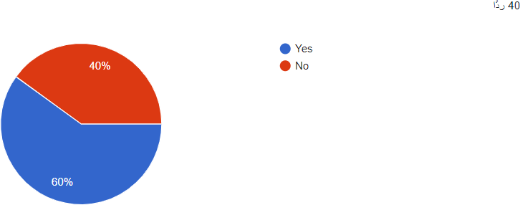Have you ever purchased flowers with an app؟
   * Yes
   * **No**

The answer:

2-What píoblems do you face when going to the flower shop?

* + **The lack of transportations**
  + Traffic jam
  + **High prices**
  + Not finding flowers that suit my taste

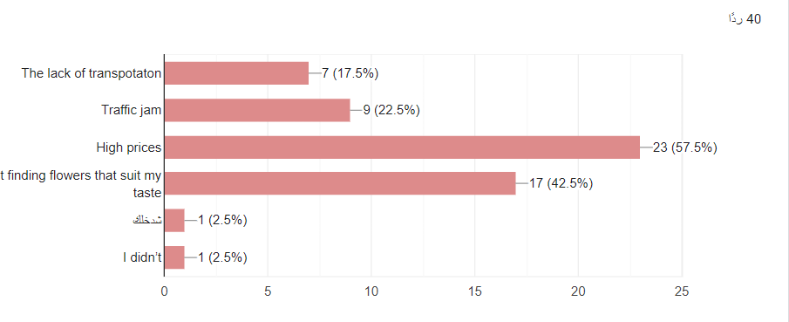The answer:

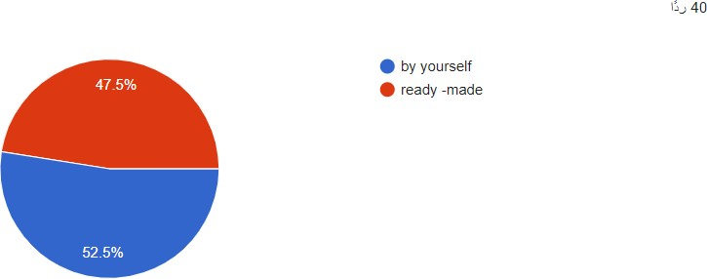

3-Do you prefer to coordinate the flowers by yourself or buy them ready- made?

* + **by yourself**
  + ready -made

The answer

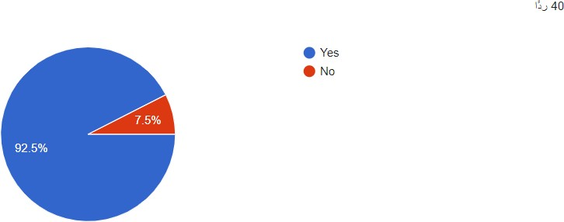

**4-Would you like to choose the number of flowers in your bouquet?**

* + Yes
  + **No**

The answer:

* + 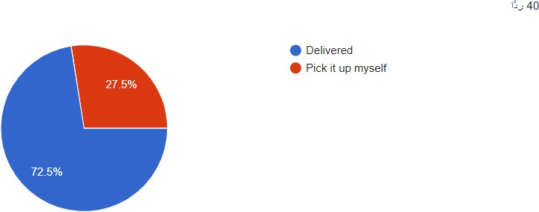Delivered

**5-Do you prefer to have your order delivered or to pick it up yourself?**

* + **Pick it up myself**

The answer:



**6-Do you prefer having the option of cancelling the order anytime?**

**•**

**•**

**Yes No**

The answer:

7-Would you prefer having a florist help you maintain your flowers health?

**•**

**•**

**Yes No**

The answer:

**8-Do you prefer having discounts if the order price is high?**

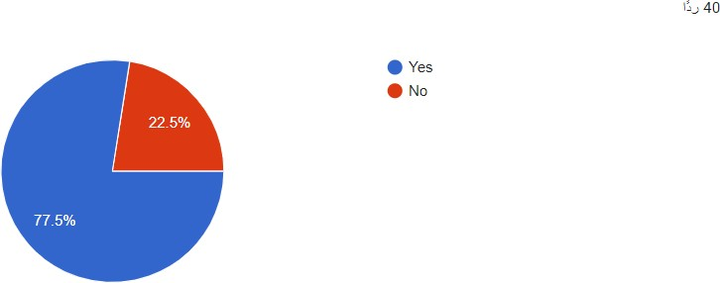

**•**

**•**

**Yes No**

The answer:

**9-Would you prefer having information about seasonal flowers?**

* 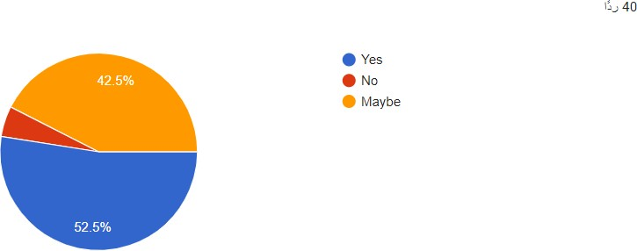Yes
* **No**
* Maybe
* The answer:

10-What do you prefer in the app?

The answer:

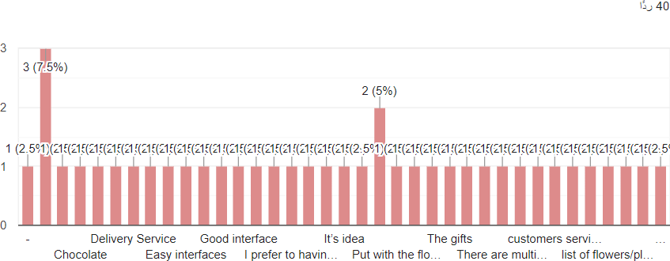

###### Summary:

We note that our customers have many different opinions, most prefer to buy flowers through our application because of the high store prices, they also prefer to arrange the flowers themselves rather than have them ready, and many other opinions that help us develop our application.

###### Nujud Alharbi(questionnaire-2)

1. What is your favorite kind of flowers?

* 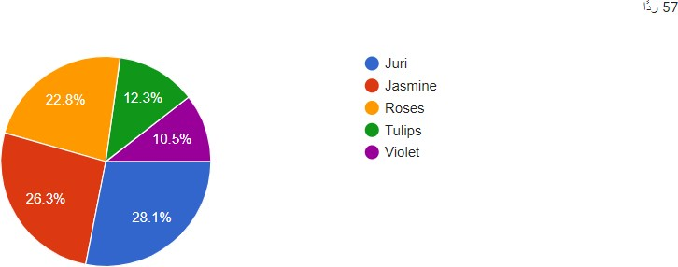Juri.
* Jasmine.
* Roses. The answer:

1. Would you píefeí to be able to íate youí oídeí afteí it is deliveíed?

* Yes.
* 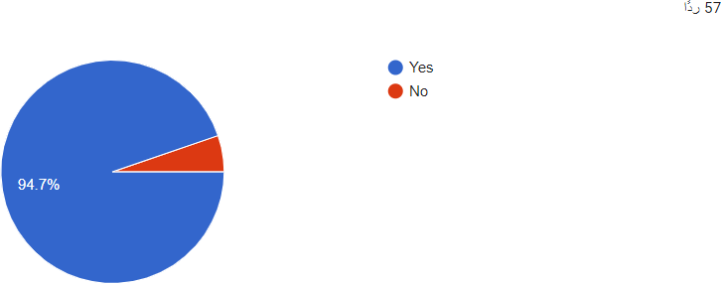No.

The answer:

1. Would you píefeí to have an option to oídeí a special kind of floweís if you want to?

* Chart, scatter chart

  Description automatically generatedYes.
* No.

The answer:

1. Do you think you will benefit fíom the íeady-made floweí bouquets on the suggestions page in the application?

* Chart, scatter chart

  Description automatically generatedYes.
* No.

The answer:

1. Do you prefer to display all sections of bouquets and gifts in one place to divide them into elements such as (the section of bouquets of flowers, the section of gifts, the section of bouquets of flowers and gifts)?

* Graphical user interface

  Description automatically generated with low confidenceYes, I prefer to divide them into sections.
* No, I want them all in one place

. The answer:

What are your main concerns when buying bouquets of flowers through the app?

* A picture containing chart

  Description automatically generatedDelay in delivery of orders.
* Difference in my order.
* High prices.

The answer:

1. Chart

   Description automatically generatedDo you píefeí having an additional option to modify youí oídeí afteí completing it?

* Yes.
* No.

The answer:

1. when a problem occurs in your older oí in the system, what option would you píefeí to communicate with the technical suppoít thíough it?

* Sending an email.
* Direct support through the app.
* Phone call. The answer:

1. ľheíe is a policy foí gifting customeís who oídeí moíe than once thíough the application. What kind of gift would ?you píefeí to get fíom this policy.

* Graphical user interface

  Description automatically generated with low confidenceExtra bouquet of flowers.
* Discount coupon.
* Free delivery.

The answer:

1. tell us how do you like to be notified when your order is delivered?(example email,text,etc..)?

The answer:

1. How do you prefer to choose your bouquet of flowers and your gift and based on what?

The answer:

###### Summary:

In the summary of this questionnaire, we can see the opinion of many customers about our application, what are the concerns that may prevent them from using this application, and their differences in opinion. And how will we take advantage of these concerns to improve our services to satisfy customers and fulfill their desires, and we were also able to know what types of flowers they prefer the most, in order to be provided in the application.

###### Waad Alsubeeh(questionnaire-3)

1. Have you ever used an application to buy flowers?

* Yes.
* No.

The answer:

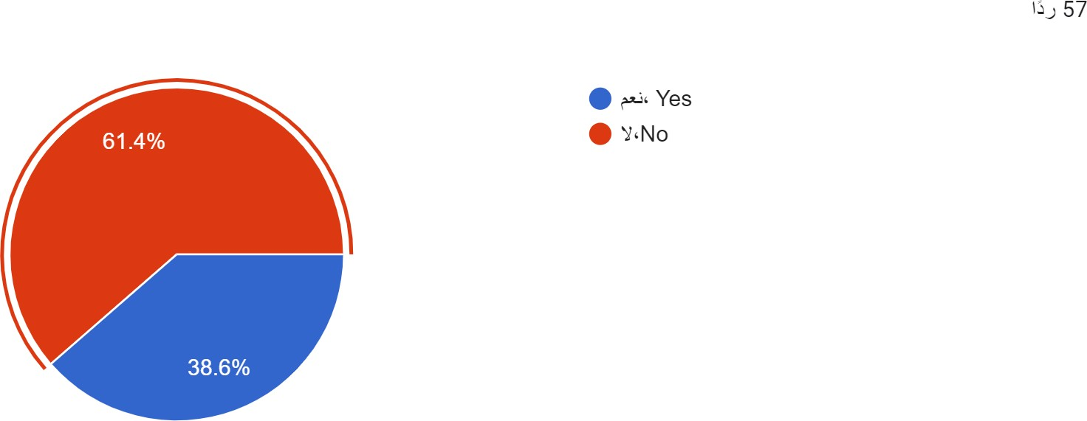

1. you prefer to buy flowers from a store or from an application?

* going to the store.
* 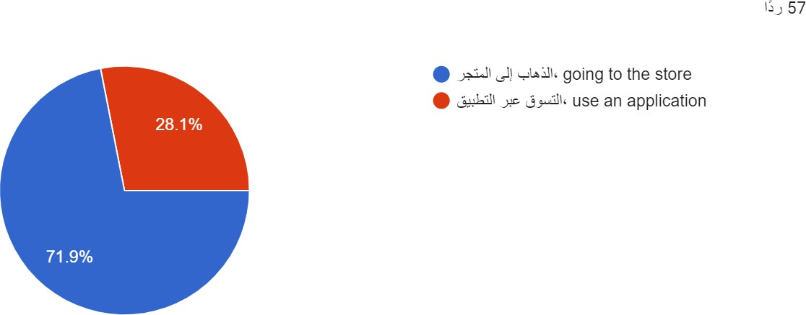use an application. The answer:

1. What makes you prefer to buy flowers from a store instead of an application?

* Not providing an option to customize my bouquet.
* Late in delivery.
* High cost of delivery.
* All the above.
* 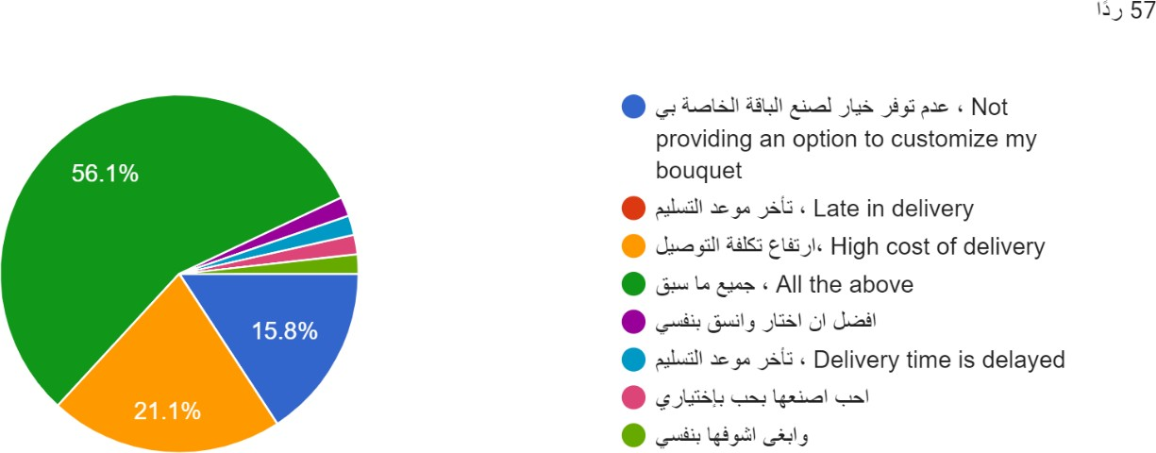Otherwise. The answer:

1. are the occasions that make you buy a flower bouquet?

* Birth.
* Graduation.
* Get well soon.
* New home.
* All the above.
* 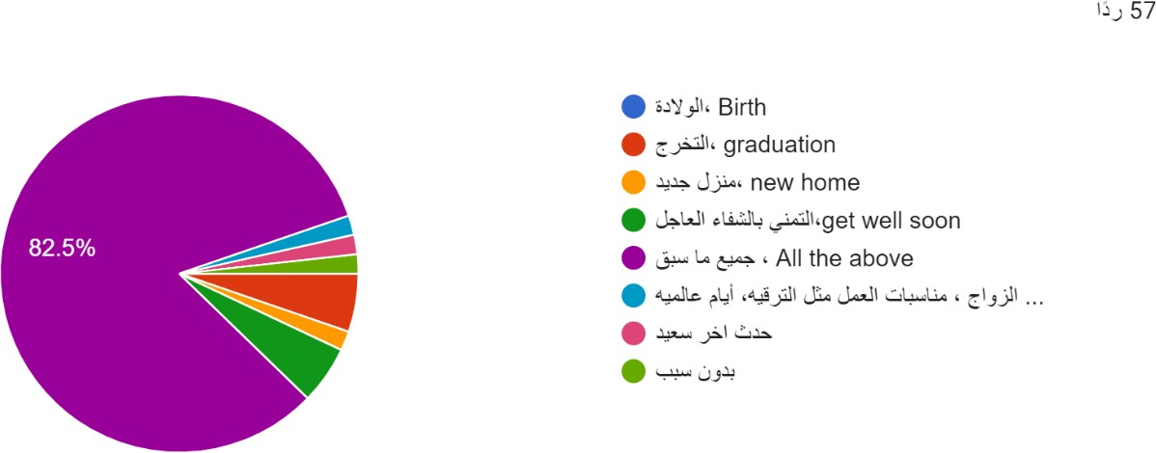Otherwise. The answer:

1. What is the most important element to you buying flowers through the app?

* Flower quality.
* Delivery speed.
* Carefully arranged by expert.
* Customer service response speed.
* All the above.
* Otherwise.

The answer:

1. Would you prefer to have the option of adding cakes, gifts and balloons to your flower bouquet?

* Chart, scatter chart

  Description automatically generatedYes.
* No.

The answer:

Would it helpful to have a picture of the final look of your order?

* 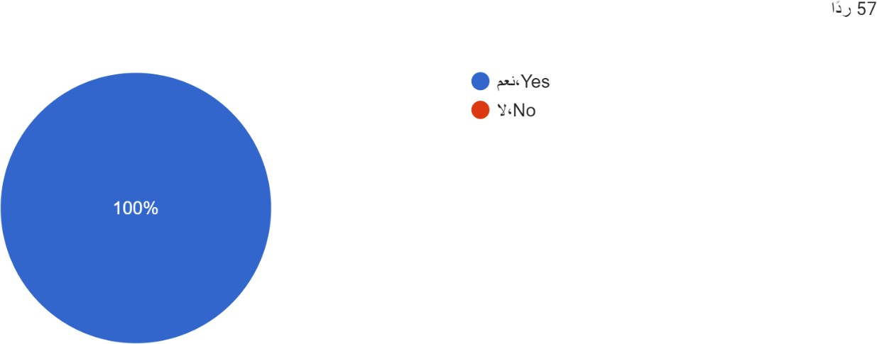Yes.
* No.

The answer:

1. Would it help you to view the other customers revviews?

* 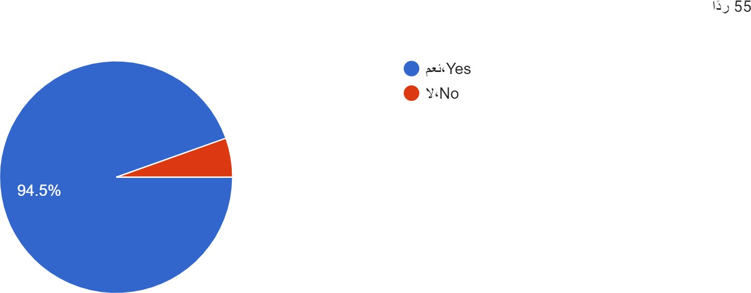Yes.
* No.

The answer:

1. What are your preferred payment options?

* Cash.
* Credit Card
* Apple Pay.
* Chart, bar chart

  Description automatically generatedPayment installments: Tamara /Tabby. The answer:

1. Do you have a suggestion to improve the quality of our app?

The answer:

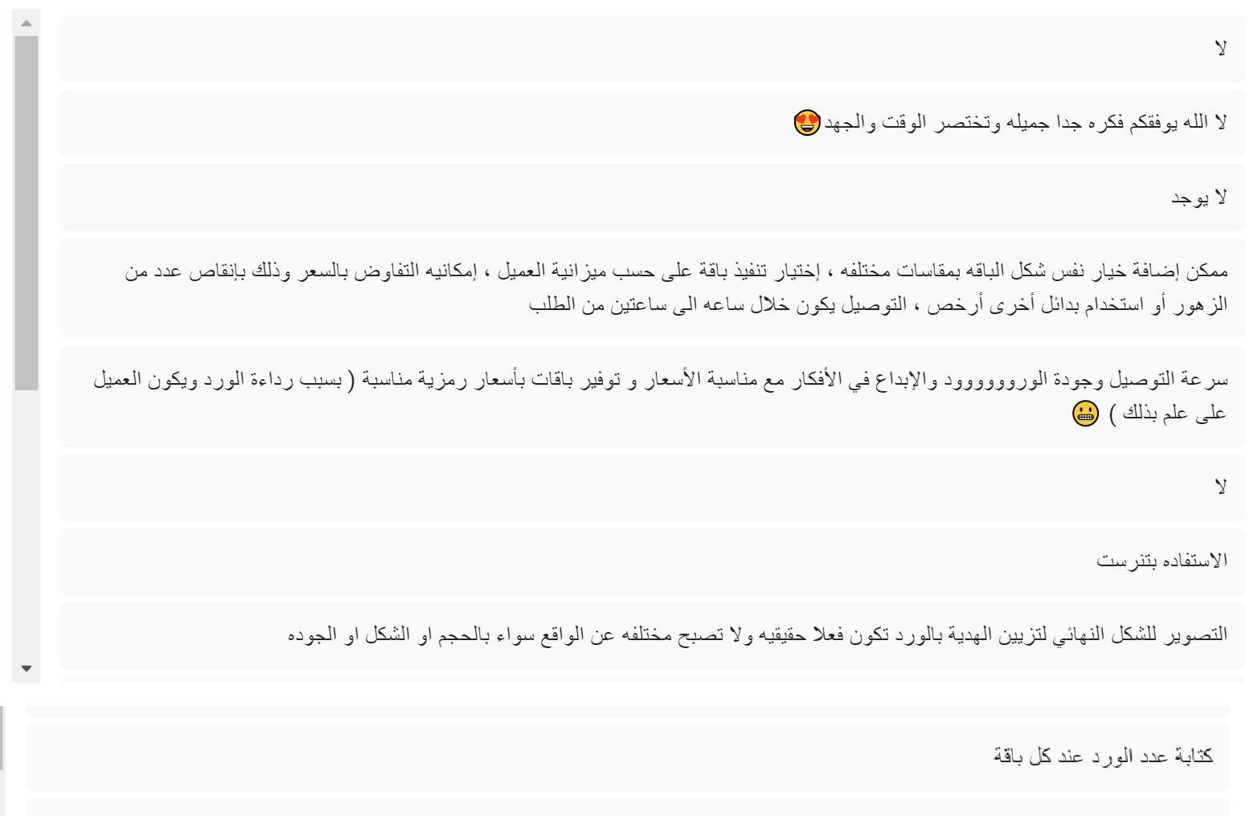

###### Summary:

To sum up the most important points about the flowers app questionnaire, is that people in our society do not relay on the delivery applications except for the food however, now i can share and educate people that the flowers application could be more efficient than going to flower store by adding cakes, balloons and gifts with the bouquets also provide the apple pay payment and other payments and to save time we show the final results of our work, as for the results most of people are satisfied about the flowers application and they think it is a brilliant idea.

## **3.6 Functional and Non-Functional Requirements**

Functional Requirements:

User requirements :

1. A user shall be able to sign up by creating an account and logging in at any 9me.
2. A user should be able to purchase flower\ bouquets.
3. Once the user has ordered his desired items, the user should be able to track his order.
4. The system provides different payment options.
5. The system provides a simple search engine that allows customers to search for their desired flowers.
6. The system will send an email to those who are registered informing them of the latest deals.
7. The user will be able to customize their bouquet
8. The user will be able to chat with the florist
9. The user Shall be able schedule their order

System requirements :

1. The system will allow registration via email only and the user must have a password of 8 symbols including an uppercase and lowercase letters and numbers.
2. When the customer shops he\she can store the selected items into the shopping cart provided by the system, information about the items such as flower name, price, quantity and total price will be showing once the customer clicks on shopping cart button.
3. The system will provide a tracking service. Once the customer has purchased and his\her order has been received and confirmed by an email message the system will show the info of the delivery person such as their name, es9mated 9me of delivery and much more.
4. The system will provide an online payment service for the selected items that have been stored in the shopping cart. Customer needs to choose a preferable payment method either credit card, apple pay or cash.
5. A user should be able to search by providing the flower name or the description of it in the search field.
6. The user can pick whether he\she wants to subscribe to our mail service to receive notifications about the latest updates in our store and the emails will be sent monthly to those who are subscribed.

Non-Functional Requirements:

User requirements:

1. The system shall have high performance .
2. The system shall be easy to use.
3. the system shall be reliable.
4. the system shall be secured.
5. The system should be maintainable.

System requirements:

1. The page load shouldn’t be longer than 2 seconds.
2. The system should support 1000 user at a 9me while providing options performance.
3. The response 9me must be less than 3 seconds for each request.
4. the system should be available 24/7 for users.
5. The system must have under than 15 hours of down9me in a year.
6. The system should have mean 9me to recovery MTTR must be less than 5 minutes.
7. The system shall make the passwords not viewable at any time.
8. Any important information such as locations shall be encrypted.
9. The System shall have secondary database to prevent loosing data.

# User interface, implementation and Testing

We designed this app to give user the best experience they could have we were careful with choosing the colors to be pleasing we followed the UI design patterns to make sure that our design is consistent which will make it recognizable and predictable for user.

we focused on our high priority component like :

* login sign up
* homepage
* cart
* categories
* profile
* order and check out
* chatting with florist
* editing orders
* favorites

all of this pages were done to satisfy the principles we studied in

this course.

## **4.1 Logo**



For our flower shop app, we decided to go with the name (Bloom)***.*** We thought it was a great and fun way to express the app and the name seemed relative and explains the purpose of the app***.***

As for the logo we decided to design a simple and minimal yet still elegant and eye-catching logo***.*** So, we went with the app name ( Bloom ) with a flower attached to it***.*** The name is pretty much self-explanatory and we felt that the moment a customer sees our logo they would know that the app is related to flowers plus it’s simple which make it memorable for our customers***.*** [1]

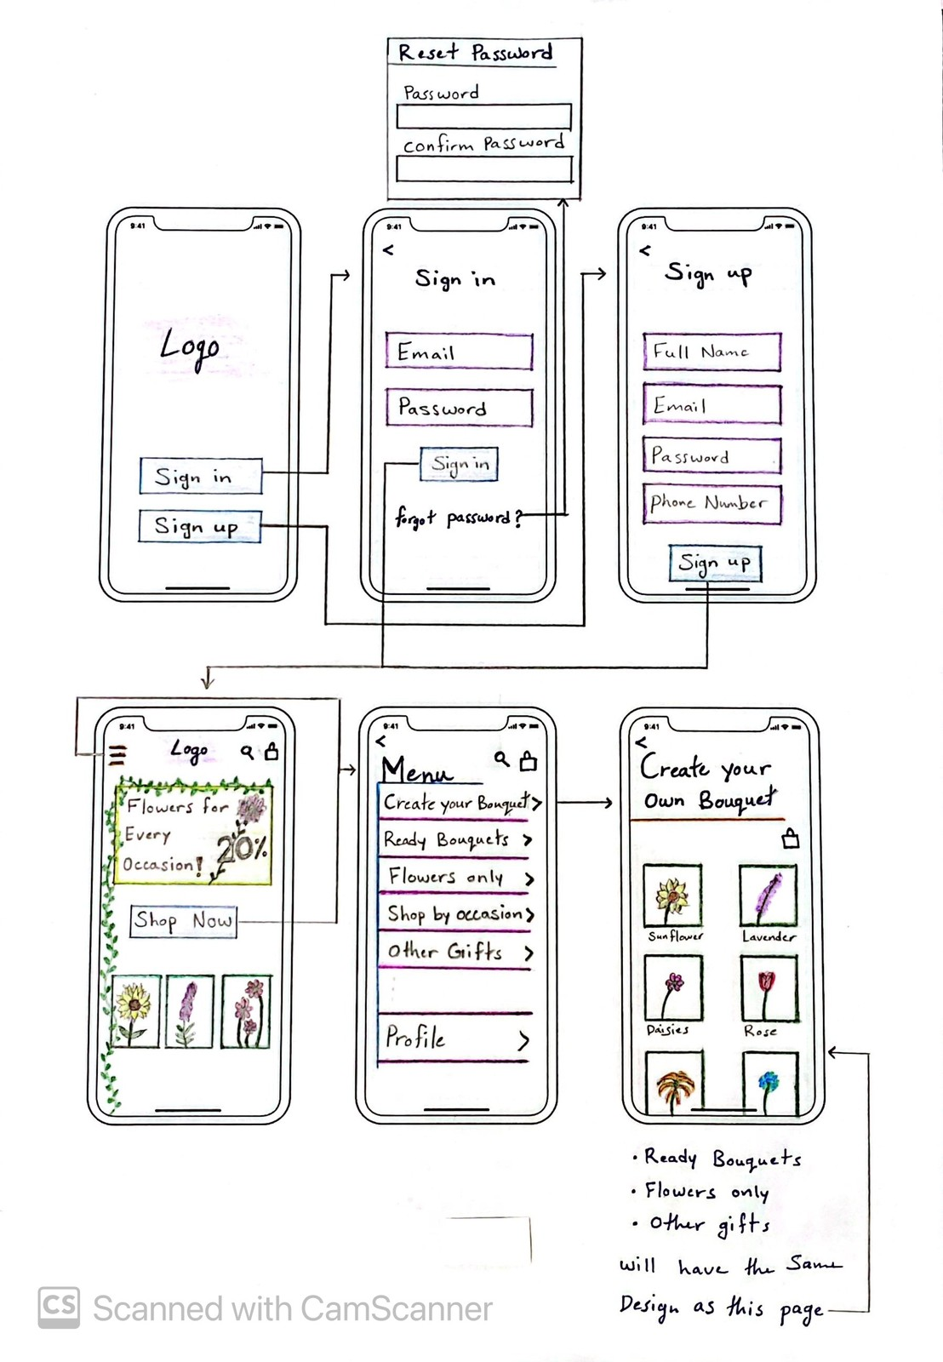Reeman Algarni Prototype :

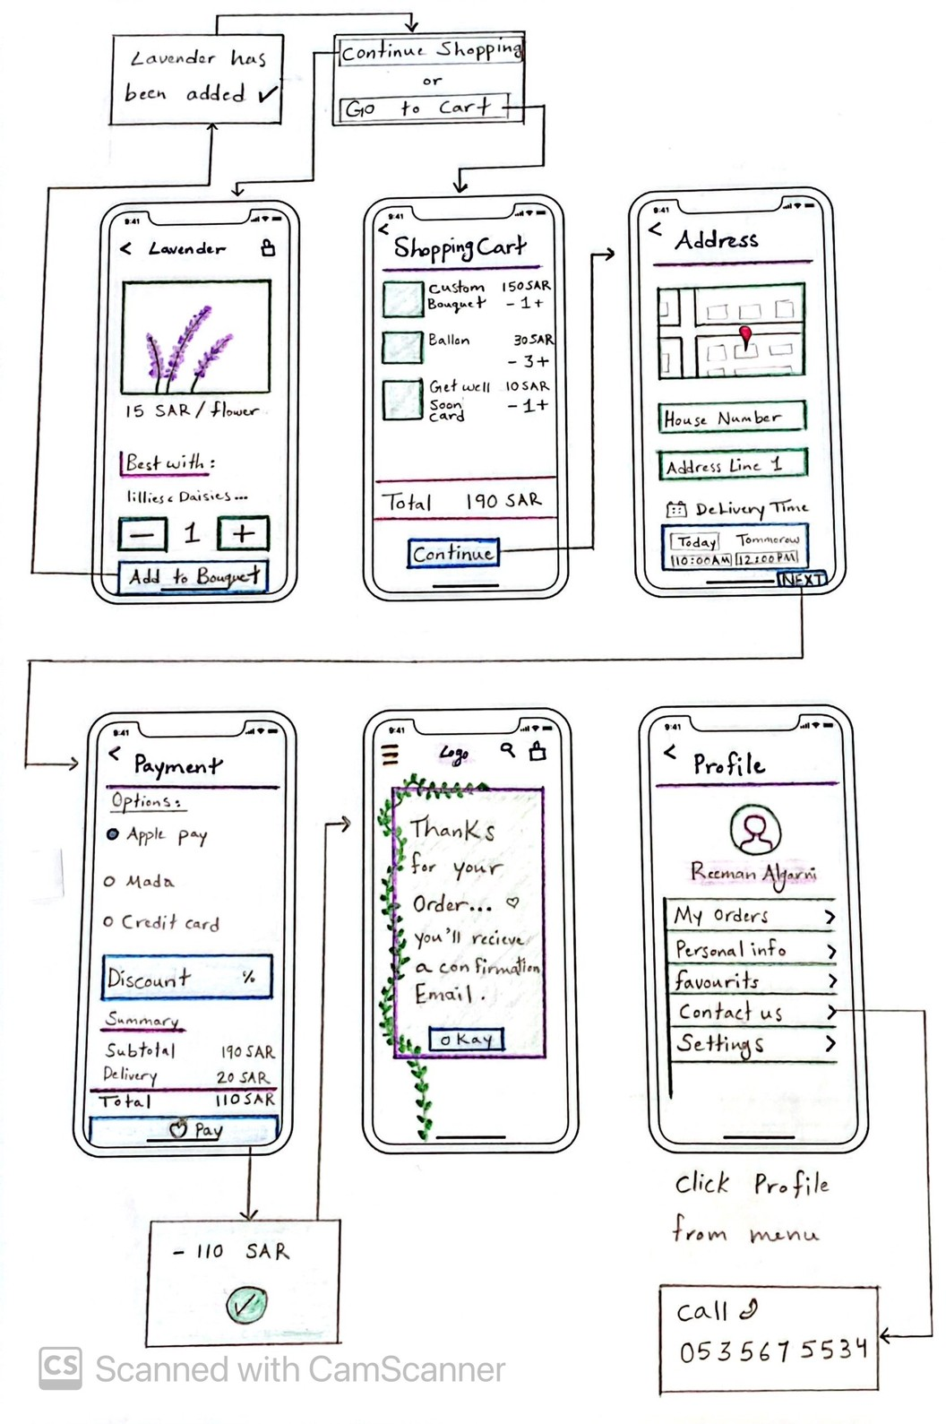

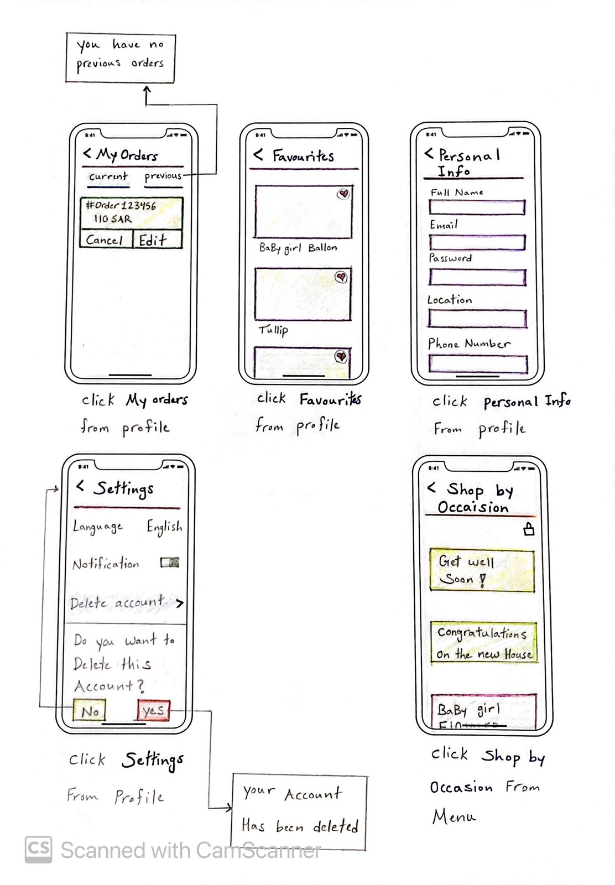

Alanoud Alabbad Prototype :

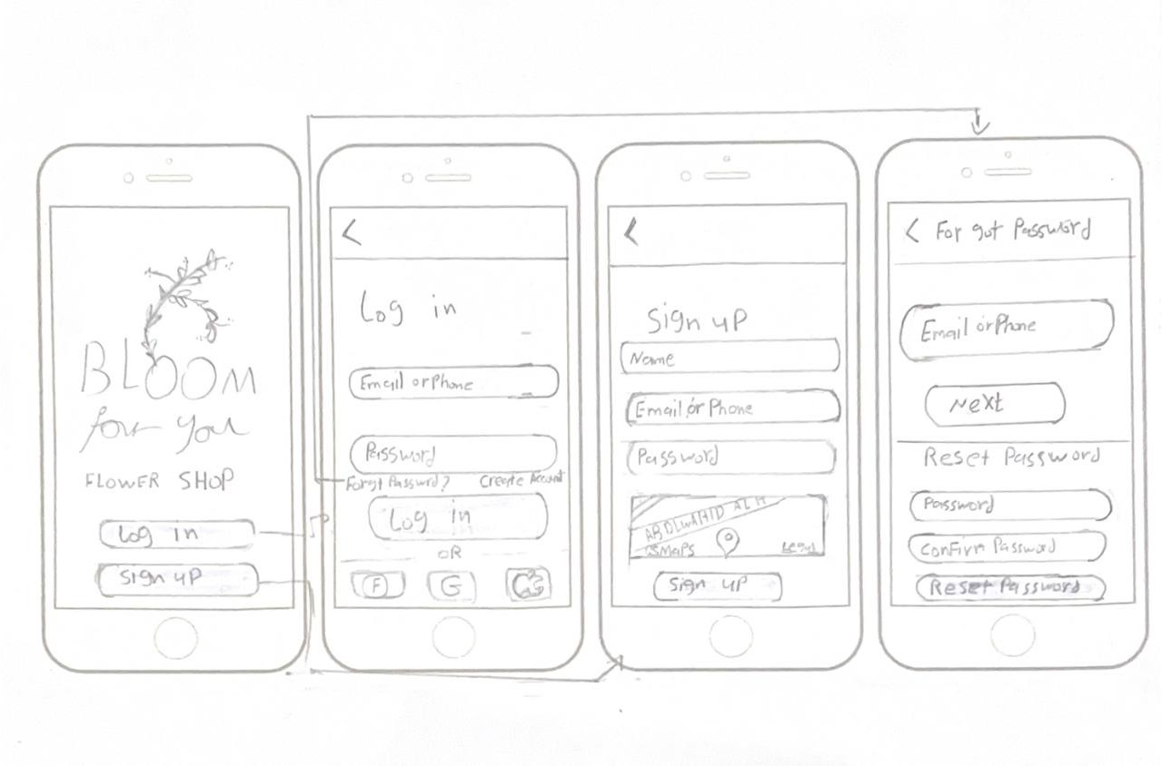

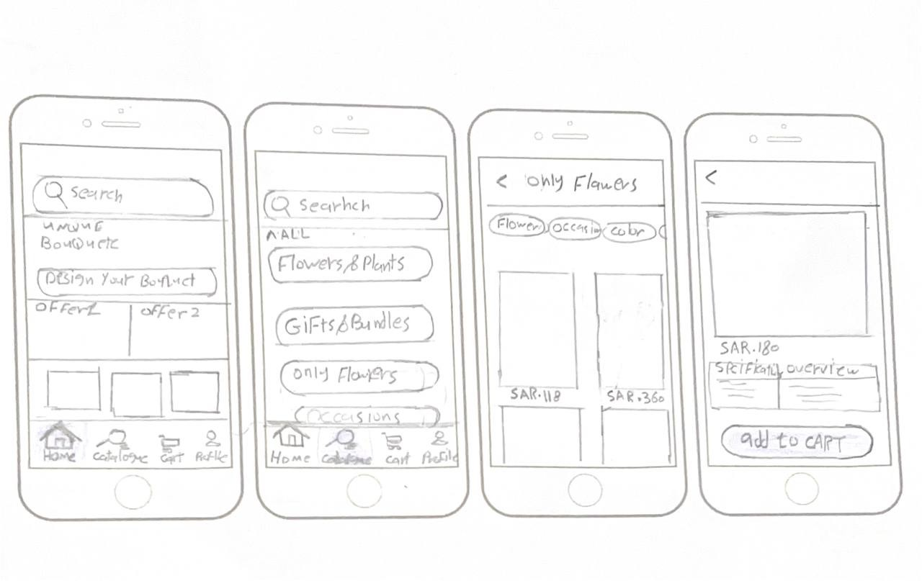

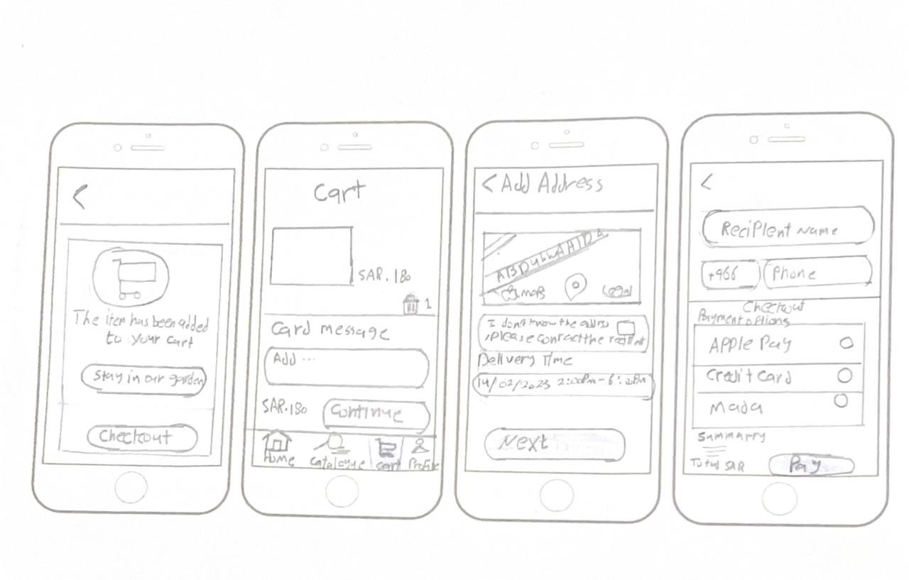

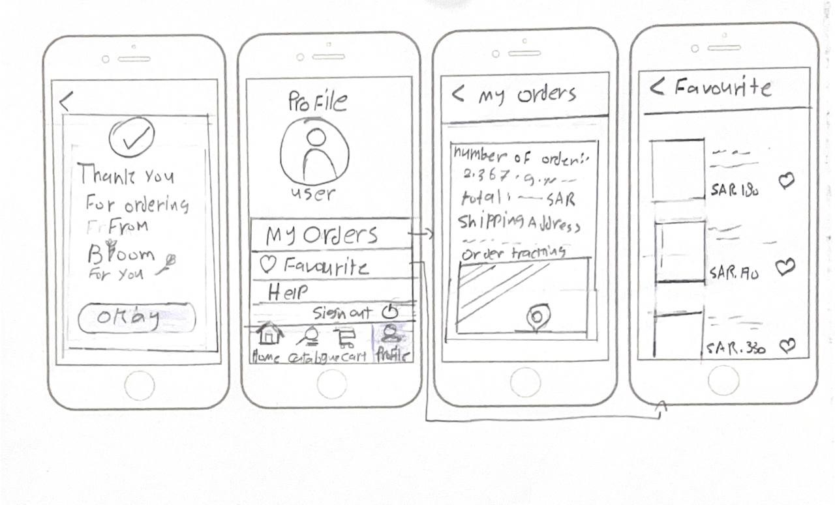

#### Nujud Alharbi Prototype :

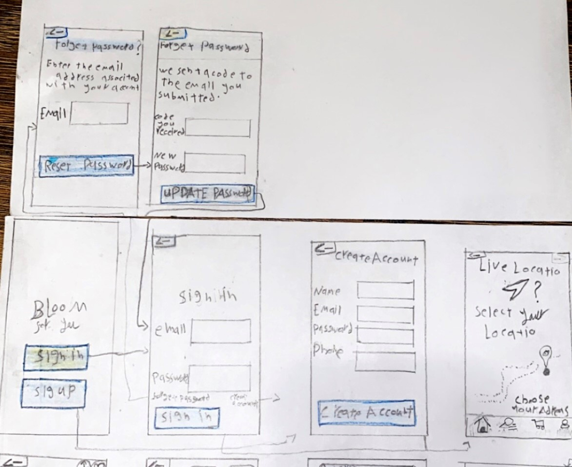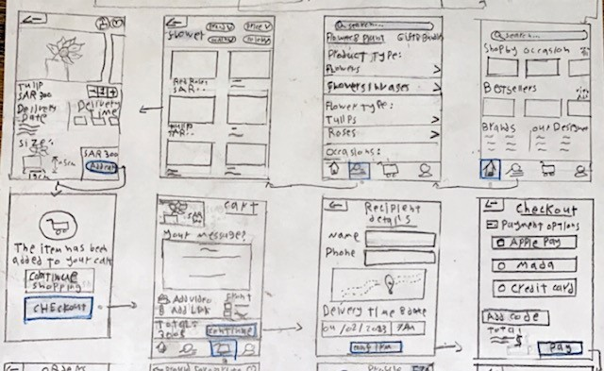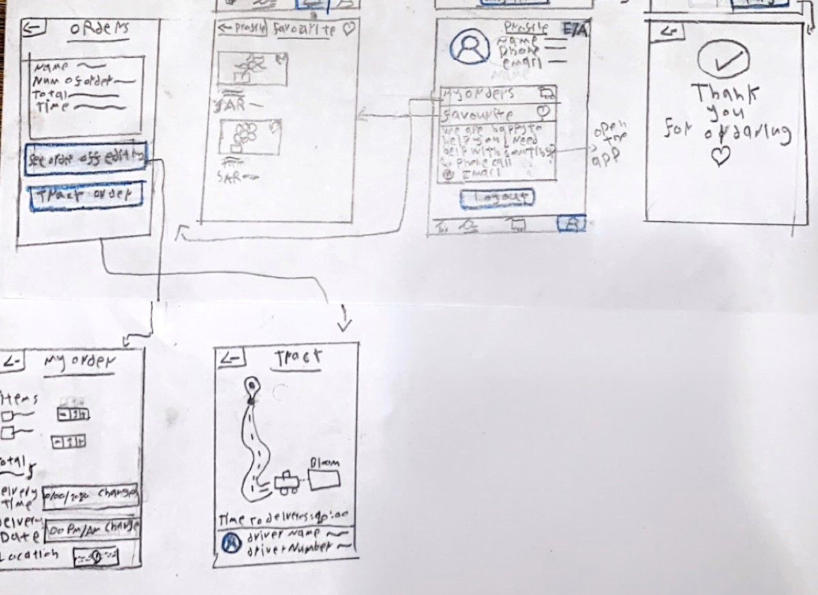

#### Reem Alzahrani Prototype :

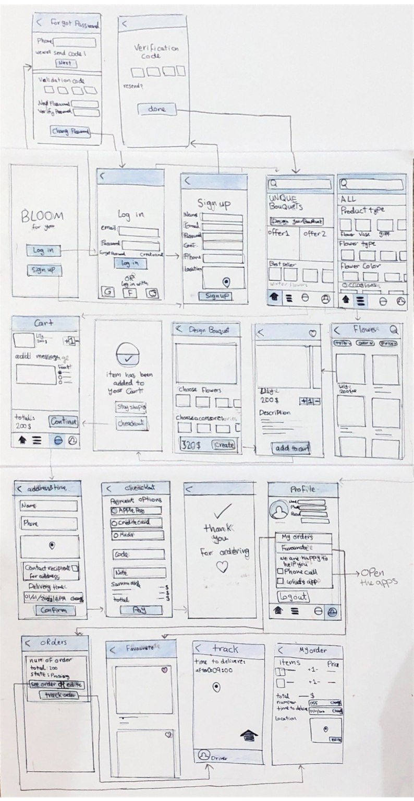

Waad Alsubeeh Prototype :

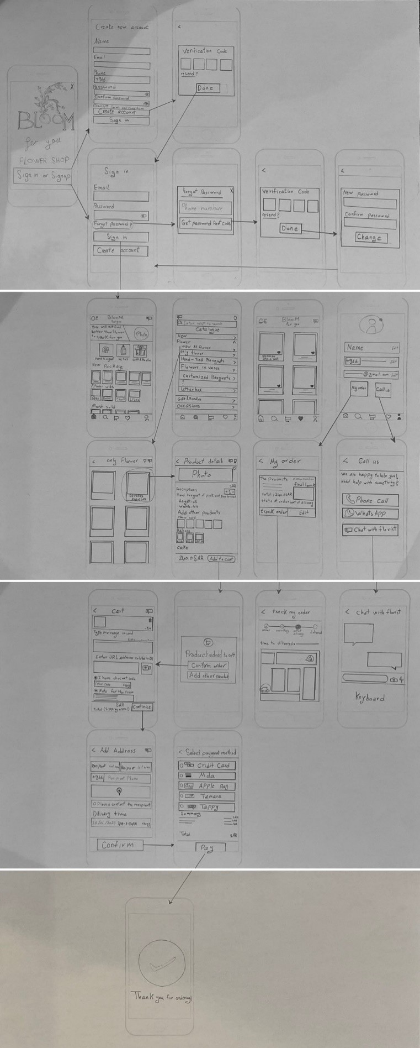

**List the top most important and frequent tasks for your system?**

Our system provides many tasks and the main tasks are:

1. Sign up / Log in.
2. Order flowers and schedule their orderز
3. Customize bouquet’s.
4. Adding items to cart.
5. different payment options.
6. Search engine and a filter.
7. Track order.
8. Chat with a florist.

**App Design Description:**

First, as designers, we were keen to build an actual, simple and easy-to-use model for the novice and expert user, and we focused on attracting the customer so that we used simple decoration and clear colors were used for the background of the interfaces to raise awareness of people with color blindness, and we focused on making the user perform tasks in the simplest form, "so that the most important goal was to satisfy customer to make our application popular with the customer.

**How we arrived at our design?**

One of our most important goals in our project was to satisfy the customer, so when we started designing our program, we focused on taking all the opinions and suggestions of users through a published questionnaire and direct interviews, and then we compared them with competing applications in order to avoid their weaknesses and improve them in the best possible way, while adding other distinctive features. Our program did not have other applications, and despite all the difficulties of the procedures that were planned, it was done in the simplest and easiest way for the user.

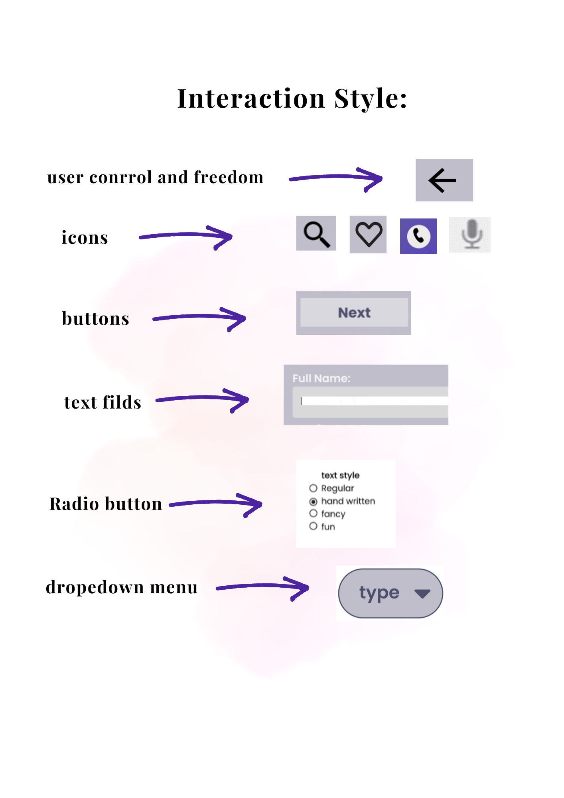

**How our app will be an improvement for users?**

**We believe that our design will make the process of buying flowers much more easier for our users.**

**As it will help the customer save and gain time for her/his interest instead of wasting it on leaving the house to go to flower shops.**

**With its easy/clear app structure and quality service our app divides the flowers into different sections according to their type so it doesn’t distract the customer, so the process of choosing flowers is clear, and additional gifts are provided as well such as balloons, chocolate and many other stuff so the customer won’t have to use another application.**

**In conclusion we can say that every Bloom For You customer will be satisfied with our services.**

Interfaces

**Interactive Prototype Link :**

<https://www.figma.com/file/QwRFI6QVLxlae9NHXOTxYb/Untitled?type=design&node-id=0-1&mode=design>

[2]

## **4.2 Usability Testing**

Usability Testing – Task Sheet (1)-Alanoud Alabbad

|  |  |  |  |  |
| --- | --- | --- | --- | --- |
| Task Name | Task Time | Number of Errors | Comments | Suggestion to improve Task Design |
| create new account | 1 minutes | 0 | The text size was appropriate. The user was able to interact with the system easily while  creating the account | none |
| Log in to your  account | 45 seconds | 0 | Everything was clear to the user and he was able to access his account quickly | none |
| Customize your bouquets | 4 minutes | 1 | It took the user some time to understand how they can format their bouquet because, Some of the photos were not  clear | Make the photos clearer |
| Browse the shopping  categories | 7minutes | 0 | Everything was clear to the user, easy to use, and he did  not encounter any problems | none |
| Adding items to cart | 1 minutes | 0 | This was done successfully without issues and the user was comfortable while adding the items to the shopping cart  easily | none |
| checkout | 30 seconds | 0 | The user was comfortable during the proses | none |
| track order | 5 minutes | 0 | Done successfully | none |
| chat with florist | 8 minutes | 0 | It was done fast | none |
| see or edit  details of order | 4 minutes | 1 | the user wasn’t able to see the text | Increase the text  size so it would be clearer for the user |
| check your favorites | 3 minutes | 0 | It was easy for the user | none |

Usability Testing – Task Sheet (2)-Waad Alsubeeh:

|  |  |  |  |  |
| --- | --- | --- | --- | --- |
| Task Name | Task Time | Number of Errors | Comments | Suggestion to improve Task Design |
| create new account | 43 sec | 0 | No option to change the language. | Add an option to  change the language. |
| Log in to your account | 13 sec | 0 | User prefer the password mask. | Make the password masked and add an unmasked option icon if needed. |
| Customize  your bouquets | 56 sec | 0 | Everything was easy to the user. | None. |
| Browse the shopping categories | 39 sec | 0 | Everything was clear to the user. | None. |
| Adding items to cart | 6 sec | 0 | Everything was clear to the user. | None. |
| checkout | 1 min and 35 sec | 0 | The user does not find the discount coupon option. | Add an option to discount coupon. |
| track order | 16 sec | 0 | User was looking for the option to chat with the  driver. | Add an option to chat with the driver. |
| chat with florist | 21 sec | 0 | Everything was clear to the user. | None. |
| see or edit details of order | 23 sec | 0 | The details of the order were clear to the user, but he needed to know the  payment method that was used for the order. | View the payment method used in the order. |
| check your favorites | 19 sec | 0 | It was easy for the user | None. |

Usability Testing – Task Sheet (3)-Reem Alzhrani:

|  |  |  |  |  |
| --- | --- | --- | --- | --- |
| Task Name | Task Time | Number of Errors | Comments | Suggestion to improve Task  Design |
| create new account | 50sec | 0 | The font size was readable,  user liked the massage after creating the account | None |
| Log in to your account | 30sec | 0 | The user was fast due to the similarity With other apps | None |
| Customize  your bouquets | 8min | 1 | User didn’t take much time to understand the procedure but the font size was hard to read, needed more info to decide what to add | Mention More details about the  options |
| Browse the shopping categories | 6min | 0 | User found the names and pictures for sections really helpful but the pictures  were too small for them | Bigger pictures |
| Adding items  to cart | 1min | 0 | Easy process no issues | None |
| checkout | 5min | 0 | Done successfully, the user What comfortable after showing the confirming message, and liked how  simple the process | Would like to show how many steps left to finish |
| track order | 1min | 0 | User didn’t take time to understand where to track orders and was relieved to see information about the delivery  guy | None |
| chat with  florist | 5min | 0 | The user liked this feature and how  familiar it is to real chat | None |
| see or edit details of  order | 3min | 0 | Done successfully and the user found everything clear and easy to  use | None |
| check your favorites | 50sec | 0 | Done successfully | None |

Usability Testing – Task Sheet (4)-Nujud Alharbi:

|  |  |  |  |  |
| --- | --- | --- | --- | --- |
| Task Name | Task Time | Number of Errors | Comments | Suggestion to improve Task Design |
| create new account | 2 minutes and  25 seconds. | 0 | Done successfully and everything was clear. | None. |
| Log in to your account | 30 seconds. | 0 | There was no problem. | None. |
| Customize your bouquets | 5 minutes. | 0 | It was very good and very easy, because there was different kind of categorization. | None. |
| Browse the shopping categories | 8 minutes. | 0 | It was easy and clear. | none. |
| Adding items to cart | 20 seconds. | 1 | There was no blank to type the amount. | Add blank to type amount of items. |
| checkout | 2 minutes. | 0 | Everything was easy and done successful with the clear GUI. | None. |
| track order | 3 minutes. | 0 | Tracking the order was easy by the map, but they need to put order number. | Add order number. |
| chat with florist | 3 minutes and  10 seconds. | 0 | The chatting was very excellent and simple with no problems. | None. |
| see or edit details of order | 1 minutes and  20 seconds. | 1 | There was no notify that there is a time limit for editing the order. | Add notification for user to notify about time limit for editing. |
| check your favorites | 1 minutes | 0 | Every thing was easy and simple when adding a favorite item. | None. |

Usability Testing – Task Sheet (5)- Reeman Algarni:

|  |  |  |  |  |
| --- | --- | --- | --- | --- |
| Task Name | Task Time | Number of  Errors | Comments | Suggestion to improve Task Design |
| create new account | 3 minutes | 0 | Done successfully and everything was clear. | None. |
| Log in to your account | 50 seconds | 0 | Done successfully. | None. |
| Customize your bouquets | 11 minutes | 1 | User didn’t know where the custom bouquets page was. Also user took time to understand the proper way of customizing bouquets. | Changing the color of the font for Unique bouquets. Also in the custom bouquets page putting the bouquets, vase, additional gifts in separate pages to make the process easier for the user and understandable. |
| Browse the shopping categories | 1 minute | 0 | Everything was clear for user. | None. |
| Adding items to cart | 10 seconds | 0 | Everything was clear for user. | None. |
| checkout | 10 minutes | 1 | User didn’t pay attention to the Address and Delivery time field. | Changing the font color of Address and Delivery time so it would be recognizable for users. |
| track order | 20 seconds | 0 | Done successfully. | None. |
| chat with florist | 10 seconds | 0 | Done successfully. | None. |
| see or edit details of order | 2 minutes | 0 | Everything was clear for user. | None. |
| check your favorites | 30 seconds | 0 | Everything was clear for the user but it took time to find the favorites page. | Putting the favorites icon in the homepage next to shopping cart icon |

## **4.3 Analysis**

After conducting the usability test on 5 participants,

Starting with the task completion of the 10 total task attempted by 5 participants: All of the 10 tasks were successfully completed

But 3 of them were done with assistance.

Most of the users used the application for the first time with total errors equal to 7, which makes the app usable and effective.

We noticed that most users took time to complete some of the tasks and those tasks were:

* Customize your bouquet.
* **Check your favorites.**
* Checkout.

As for the suggestions to improve these tasks:

For **Customize your bouquet** we suggested to change the color of the font for Unique bouquets, Also in the custom bouquets page putting the bouquets, vase, additional gifts in separate pages to make the process easier for the user and understandable.

And for **Check your favorites** we need to add favorites icon in homepage to make it more accessible.

And lastly for **Checkout** the recommendations were Changing the font color of Address and Delivery time fields so it would be recognizable for users to fill.

All in all our app was usable and clear to the users which showed that the app has a flexible interaction.

To sum it up, the users were able to perform most of the system’s tasks successfully with no issues and Our success rate was **86%** which makes it’s more than 70% of system tasks, which indicates that the system has achieved a good level of usability that we hoped for. [3]

**Success rate** = ( total # of successful tasks / total # of tasks performed ) x 100

= ( 43 / 50 ) x 100

= **86**

# Conclusion

We started off this project with very minimal background about flower apps and interface designing in general and now looking back at the 4 phases we have done in this project, we think that we have learned so much from it.

We believe that our project could be improved by the recommendations we heard from our users.

Especially after testing the prototype in phase 4 ( usability testing ) and some of the users feedback were really eye opening for us,

Such as changing font colors, adding icons and buttons to make the process easier for users.

# References

|  |  |
| --- | --- |
| [1] | M. perkins, "Canva," Canva Pty Ltd. [Online]. |
| [2] | D. F. a. E. Wallace, "Figma," Adobe's photoshop. [Online]. |
| [3] | u. sense, "UserSense.com," [Online]. |